Learning Outcomes:

M01 – Measure Pupil Sheet

I can measure items in metres and centimetres and know how to convert between the two.

I can measure in Kilograms and grams and know how to convert between the two.

1. Measure the length of your classroom, at its longest point. Choose a suitable tool and record the answer below.

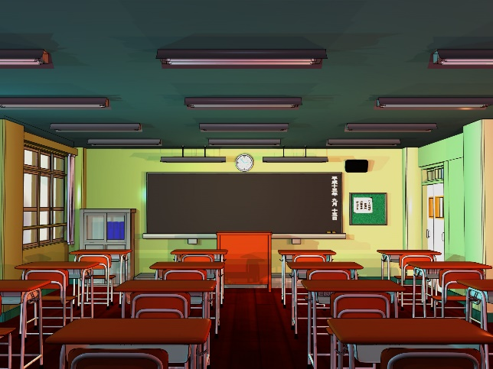

The classroom is m long, or cm.

1. Measure the length of the school playground using suitable tools.



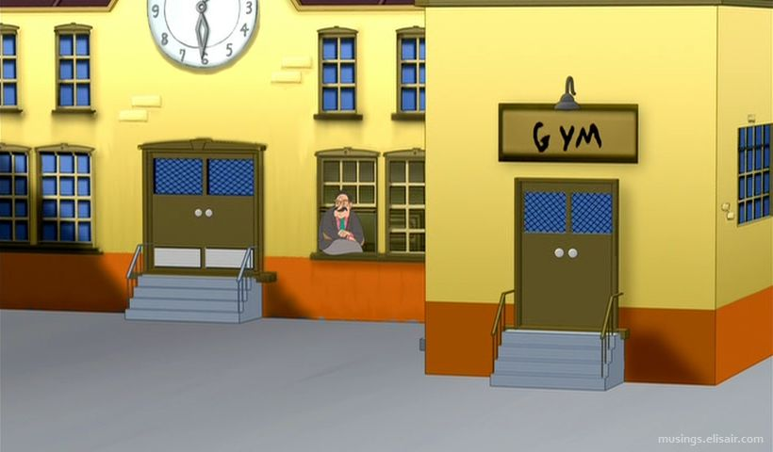

The school playground is m, and cm long.

1. Find the weight of a maths textbook using a balance and weights.

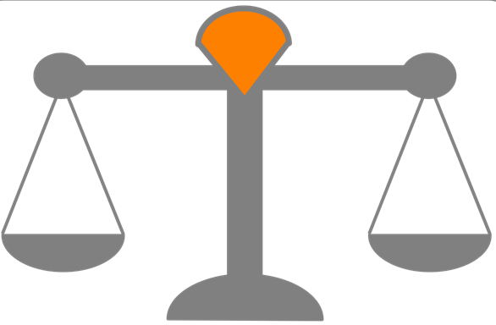

My maths textbook weighs g, or kg.

1. Using the balance, compare the weights of your textbook and your jotter.

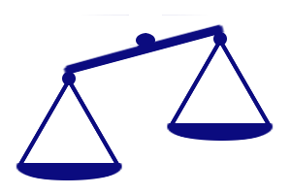

heavier

lighter

My textbook is than my jotter.

more

less

It weighs grams